Practical Task 2.1

SIT305 Mobile Application Development

Alex Brown 216012077

Contents

Subtask 1: Design UI for the App 1

Hand Drawn App UI Draft: 1

Figma App UI Draft: 2

Final App UI: 3

Subtask 2: Implement the Conversion Logic 4

Subtask 3: Research on Llama 2 4

## Subtask 1: Design UI for the App

### Hand Drawn App UI Draft:

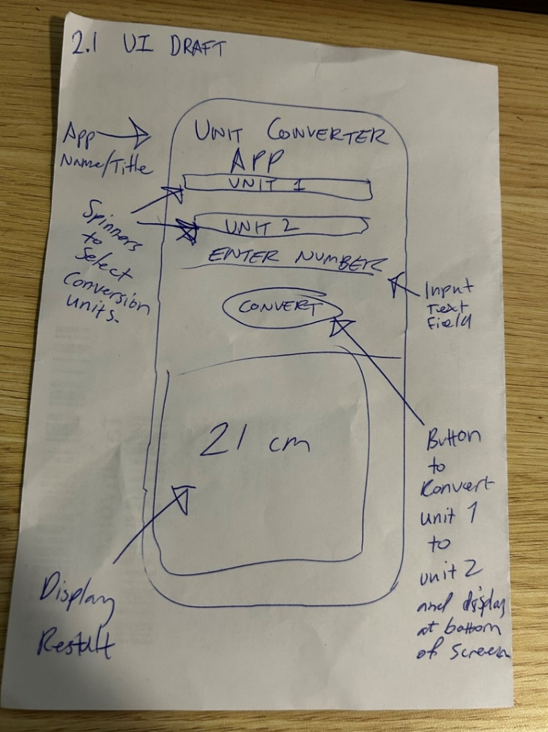

**Figure 1 – Hand Drawn Draft of the App pointing out its main UI elements and functions.**

### Figma App UI Draft:

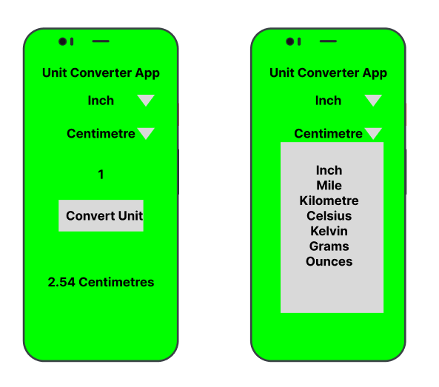

**Figure 2 - Draft the App in Figma, main App screen on left as well as an example using a spinner to select a unit to convert on the right-hand side.**

### Final App UI:

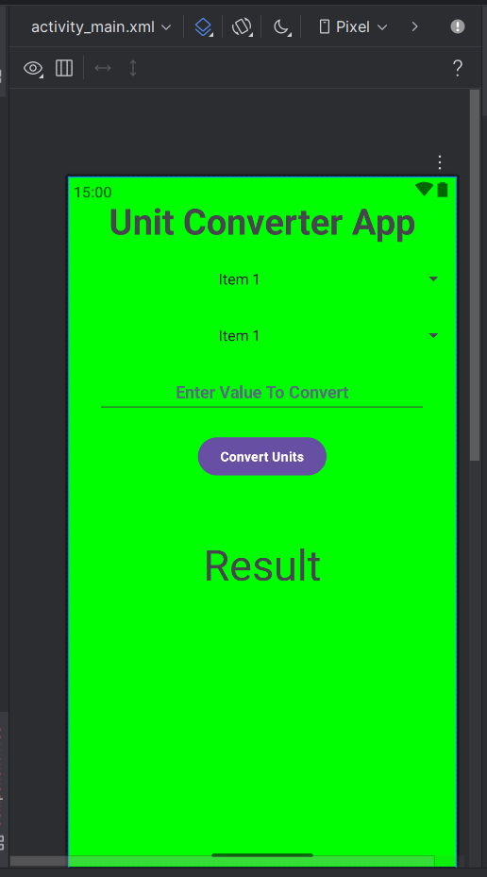

**Figure 3 - Final mock-up of the App design in Android Studio. All elements of the UI as well as colour design, fonts, spacing, sizing, and alignment are completed.**

## Subtask 2: Implement the Conversion Logic

**Link to GitHub Project:**

<https://github.com/AB-Deakin/MobileApplicationDevelopment/tree/master/Task%202.1>

**Link to YouTube Demo of App:**

<https://youtu.be/MqOvuTt34U8>

Video is also uploaded into GitHub project as 2.1-Demo.mp4

## Subtask 3: Research on Llama 2

**Word Count: 499**

The Llama2 Large Language Model or LLM was developed and released by Meta AI in 2023 and has been developed for wide scale natural language processing. The Llama2 model can be implemented with 7-70 billion parameters as required by its use case and required complexity of the models involved. As the model is trained via large text inputs it excels at producing output with human like responses and due to its open-source availability, both in research and business enterprises can continually improve and become more accurate in its generative outputs.

Some of the ideal use cases for the Llama2 model integrated into an Android app are to use it to train virtual assistants, creating responsive chat support bots, creating recommendation algorithms, summarizing content, and using it to dynamically translate language.

Using Llama2 to integrate virtual assistants in apps and train them to anticipate user needs such as scheduling, creating reminders, developing travel plans, running meetings, can make life easier for its users and adding functionality of a virtual assistant into existing apps like Calendars (making appointments and giving reminders of existing appointments and daily summaries), Maps (pre-programming routes based on calendar or email data and adjusting for travel times based on locations and traffic), or collaborative messaging and meeting apps like Teams or Slack to automatically find gaps in schedules for meetings or act as a secretary in a meeting.

With the availability of Llama2 it can be implemented into chat bots into apps, both as initial support in support apps to triage users into the correct lane for or to find a resolution for users without having to have a human intervention. Chat bots can be used in other scenarios like checking stock on an app for a retail chain, having dynamic conversation in a video game with generative responses from non-playable characters, to even training human users to respond to virtual customers in preparation for support roles.

With its vast input of data, it can also be used to generate recommendations to users by monitoring both their usage and others usage and base recommendations of movies, tv series, music, or any media based on previous likes, dislikes, and views. Adding this to an app like letterboxd or as part of Spotify’s smart AI playlist generation could provide greater results.

Llama2 can be used to summarise and clean large swaths of data taking out unnecessary data and providing users with information that can be identified in a glance, this can be seen in use currently from Meta with Facebook threads now showing AI driven summaries of comments and the responses from users.

And finally, it can also be used in apps to translate languages on the fly whether that be dedicated language apps for translating for tourists and migrants as they need by converting signs or providing translations of phrases to being used to translate content within apps like converting news articles to different languages or using generative AI to convert apps into languages not supported by developers.

### References

[1]

Pavan Belagatti, “Unpacking Meta’s Llama 2: The Next Leap in Generative AI,” *SingleStore*, Jan. 13, 2025. https://www.singlestore.com/blog/a-complete-beginners-guide-to-llama2/

[2]

M. Shrestha, “End to End LLM Application in Local using Llama2 , Flask and Android,” *Medium*, Apr. 08, 2024. https://mikalshrestha.medium.com/end-to-end-llm-application-in-local-using-llama2-flask-and-android-6bbe0ec0730d (accessed Apr. 03, 2025).

[3]

Ertugrul Portakal, “Deep Dive Into LLaMa-2 Use Cases,” *Textcortex.com*, Aug. 2023. https://textcortex.com/post/llama-2-use-cases

[4]

“Meta Llama 2,” *Meta Llama*, 2022. https://www.llama.com/llama2/

[5]

IBM, “Llana2,” *Ibm.com*, Dec. 18, 2023. https://www.ibm.com/think/topics/llama-2

[6]

Meta, “Meta and Microsoft Introduce the Next Generation of Llama,” *Meta*, Jul. 18, 2023. https://about.fb.com/news/2023/07/llama-2/